E2E-EmbedDetector: A Lightweight Entity-Embedding Model for Ethereum Phishing Detection

Abhishree Sinha
Computer Science and Engineering
SRM Institute of Science and Technology
Ghaziabad, India
as3751@srmist.edu.in
Nishchay Khanna
Computer Science and Engineering
SRM Institute of Science and Technology
Ghaziabad, India
nk5082@srmist.edu.in
Aashi Srivastava
Computer Science and Engineering
SRM Institute of Science and Technology
Ghaziabad, India
as2132@srmist.edu.in
Santosh Kumar Birthriya
Computer Science and Engineering
SRM Institute of Science and Technology
Ghaziabad, India
santoshb@srmist.edu.in
Gautami Bahuguna
Computer Science and Engineering
SRM Institute of Science and Technology
Ghaziabad, India
gb8103@srmist.edu.in

Abstract— Phishing attacks constitute a critical threat to Ethereum blockchain ecosystems. Existing approaches such as TEGDetector address this by modeling evolving transaction behaviors through Transaction Evolution Graphs (TEGs), but their multi-stage graph construction pipelines introduce substantial engineering complexity. This work presents E2E-EmbedDetector, a lightweight end-to-end neural classifier that operates directly on raw transaction records and learns entity embeddings for the From, To, and ContractAddress fields, augmented by two compact numeric features: transaction Value and a derived InputLength. Trained on a balanced corpus of 50,000 Ethereum transactions under a stratified 80/20 split, the model achieves 95.6% accuracy, an F1-score of 0.958, and ROC-AUC and PR-AUC both at 0.991. These results demonstrate that competitive detection performance is attainable through a deployable tabular architecture, without requiring explicit temporal graph construction.
Keywords—phishing detection, blockchain security, Ethereum transaction, entity embeddings, neural networks.

Introduction
The rapid growth of blockchain-based financial ecosystems has been accompanied by an equally rapid proliferation of adversarial activity. Ethereum, the world's second-largest blockchain by market capitalization, processes millions of transactions daily and hosts thousands of decentralized applications (dApps), decentralized exchanges (DEXs), and smart contract protocols. This open infrastructure makes it an attractive target for phishing attackers, who construct fraudulent contracts and deceptive addresses designed to mislead legitimate users into transferring funds to malicious destinations.
Unlike traditional web phishing, which can be mitigated through URL blocking and domain takedown, blockchain phishing is particularly damaging because transactions are irreversible by design. Once a user is deceived into signing a fraudulent transaction, funds cannot be recovered. This asymmetry places a high premium on accurate, low-latency detection before transactions are confirmed or acted upon by victims.
Existing detection approaches broadly fall into two paradigms. The first constructs explicit graph representations of transaction histories—capturing who transacts with whom and how frequently—and applies graph neural networks (GNNs) to identify anomalous structural patterns [3][4][5][6]. The second, exemplified by TEGDetector [1], extends this paradigm by incorporating temporal dynamics: transaction histories are sliced into time windows, a Transaction Evolution Graph (TEG) is built per window, and a dynamic classifier learns how phishing behavior evolves across windows using adaptive time attention. While these methods are methodologically sophisticated, they demand substantial preprocessing infrastructure—time slicing, subgraph construction, and multi-stage inference pipelines—which makes them difficult to deploy in real-time production environments.
This work explores a complementary and practically motivated direction: can an end-to-end model operating directly on raw tabular transaction records—without any graph construction—achieve competitive phishing detection performance? We propose E2E-EmbedDetector, which answers this question affirmatively. By learning compact entity embeddings for the three most semantically rich address fields (From, To, ContractAddress) and combining them with two lightweight numeric features (transaction Value and input calldata length), the model captures the relational and behavioral signals needed for accurate classification in a single training pass.
Contributions:
- We propose E2E-EmbedDetector, a lightweight end-to-end phishing detector using learned entity embeddings for From, To, and ContractAddress combined with minimal numeric features, achieving ROC-AUC and PR-AUC of 0.991 on a 50,000-transaction benchmark.
- We introduce a robust open-world encoding strategy using an <UNK> sentinel token to handle unseen addresses at inference time, a critical requirement for real deployment.
- We provide a threshold optimization procedure that selects the operating point maximizing F1-score on the validation set, yielding better precision-recall balance than a fixed 0.5 threshold.
- We offer a comprehensive conceptual and practical comparison with TEGDetector [1], identify current evaluation limitations including entity and temporal leakage, and propose rigorous benchmarking protocols for future work.

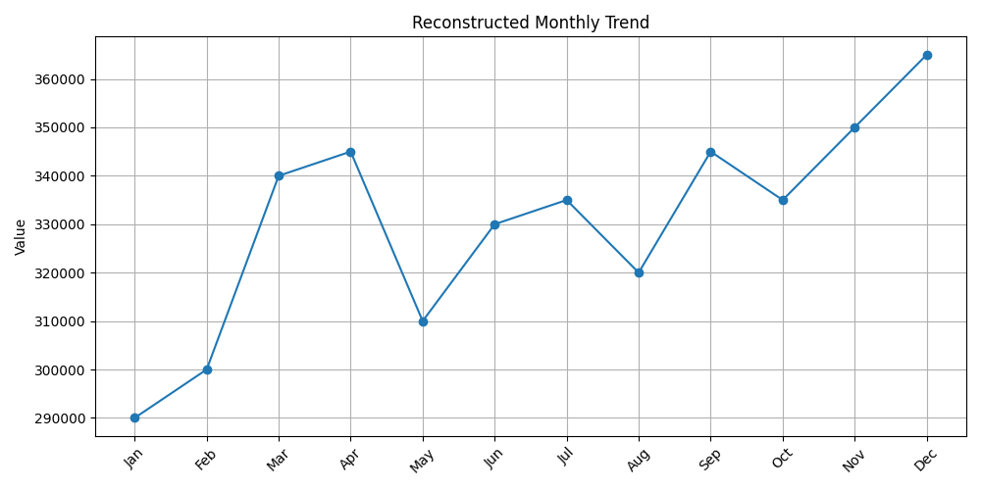
Fig. 1. Reported phishing attacks (3Q2024–2Q2025). The upward trend underscores the urgency of automated blockchain phishing detection.

Background and Related Work

TEGDetector [1].
TEGDetector models the temporal dimension of phishing by slicing transaction histories into ordered intervals, constructing a TEG per interval, and subsequently fusing spatial graph features with temporal evolution signals via learned time attention. This architecture captures behavioral drift—the gradual shift in how phishing addresses interact with targets over time [1].

Graph-based detection methods.
GNN-based approaches dominate Ethereum phishing research. Li et al. [5] frame detection as graph classification using Chebyshev-GCN on transaction subgraphs, while Li et al. [6] propose TTAGN, a temporal transaction aggregation graph network encoding time-ordered interaction. Wang et al. [10] build account-level transaction subgraph networks (TSGN) and Xia et al. [11] detect phishing via attributed ego-graph embeddings. Wu et al. [12] learn address representations through network embedding on the full Ethereum interaction graph.

Feature-based and hybrid methods.
Chen et al. [3][4] established baselines using explicit transactional features—gas usage, call patterns, transaction counts—fed into classical classifiers. Kabla et al. [7] benchmark multiple ML models under standardized feature extraction. Lin et al. [8] propose a network embedding approach for account representation learning, and Wen et al. [9] develop a hybrid deep neural network fusing multiple feature modalities for improved accuracy.

Our positioning.
Unlike the above graph-based methods, E2E-EmbedDetector requires no graph construction at all. It trades explicit temporal evolution modeling for deployment simplicity and fast tabular inference, while achieving competitive accuracy on balanced benchmark data.

Problem Formulation
Let T = {t1, t2, ..., tN} denote a corpus of Ethereum transaction records. Each transaction ti is a structured tuple containing: (i) identifier fields {TxHash, BlockHeight, TimeStamp} providing provenance and ordering information; (ii) entity fields {From, To, ContractAddress} representing the sender address, receiver address, and invoked contract address respectively; (iii) attribute fields {Value, Input} capturing the transferred Ether amount and the ABI-encoded calldata payload; and (iv) a binary label Class ∈ {0, 1}, where Class = 1 denotes a phishing-associated transaction and Class = 0 denotes a benign one.
The learning objective is to train a parametric classifier f_θ: ti → [0, 1] that maps each transaction record to a phishing probability score, such that f_θ generalizes to transactions involving addresses not seen during training. This open-world generalization requirement is a key practical constraint, as the Ethereum address space is effectively unbounded and adversarial actors continuously generate fresh addresses to evade detection.
Formally, given a labeled training set T_train = {(ti, yi)} and an unlabeled test set T_test drawn from the same or a shifted distribution, the objective is to minimize binary cross-entropy loss while maximizing PR-AUC on held-out data. The decision rule is: ŷi = 1 if f_θ(ti) ≥ τ*, where τ* is a threshold selected to maximize F1-score on the validation partition.

Dataset
The experiments are conducted on a balanced labeled dataset of 50,000 Ethereum transactions. The dataset contains an equal number of phishing-labeled (Class = 1) and benign (Class = 0) transactions, providing a 1:1 class ratio that supports stable gradient estimates during training and avoids trivial majority-class solutions. Each record includes nine fields: TxHash (transaction hash), BlockHeight (block number at confirmation), TimeStamp (Unix epoch), From (sender), To (receiver), Value (Ether transferred), ContractAddress (invoked contract, if any), Input (ABI-encoded calldata), and Class (ground-truth label).
The address fields—From, To, and ContractAddress—exhibit high cardinality. In a real Ethereum corpus, the number of unique addresses can reach tens of millions, making one-hot encoding infeasible. This motivates the use of learned dense embeddings, which compress each address into a low-dimensional vector while preserving relational structure. The Input field contains variable-length hexadecimal calldata; its raw content is not directly used—instead, its byte length (InputLength) is extracted as a compact proxy for transaction complexity. Phishing transactions frequently exhibit characteristic calldata patterns, and InputLength captures this signal without requiring ABI decoding.
Preprocessing:
Three preprocessing steps are applied. First, missing ContractAddress entries (transactions that invoke no contract) are mapped to the sentinel string 'None', enabling a consistent vocabulary entry rather than a null lookup failure. Second, missing Input field values are replaced with empty strings before length computation, so that InputLength = 0 for simple Ether-transfer transactions. Third, both numeric features (Value and InputLength) are normalized via z-score standardization using mean and standard deviation computed exclusively over the training partition, preventing any information leakage from the validation set into feature scaling.

Proposed Method: E2E-EmbedDetector

Feature Construction
The feature set is deliberately minimal, comprising only five signals: three categorical entity features (From, To, ContractAddress) and two numeric features (Value, InputLength). This minimalism is intentional—it forces the model to learn from the most semantically dense signals available in a transaction record and avoids feature engineering that may not generalize across Ethereum periods or contract types.
The choice of From, To, and ContractAddress as entity features reflects the observation that phishing activity tends to concentrate around a small set of malicious addresses that appear repeatedly across many victim transactions. By learning a dense embedding per address, the model can capture this recurrence pattern: addresses associated with many phishing transactions will receive embedding vectors that cluster together in the learned space, enabling the classifier to generalize even when a new victim address is encountered.

Safe Entity Encoding
Ethereum's address space is open-world: any 20-byte hexadecimal string is a valid address, and new addresses are generated continuously. A naive label encoder fitted on training addresses will raise a key-error when a test transaction contains an unseen address—a guaranteed failure mode in production. To handle this, we adopt safe label encoding: the vocabulary of each entity encoder is explicitly augmented with a reserved <UNK> (unknown) token during the fitting phase. At inference, any address not present in the training vocabulary is deterministically mapped to <UNK>. The model learns a dedicated embedding vector for <UNK> during training, representing the expected behavior of novel, unrecognized entities. This strategy ensures zero lookup failures and provides a meaningful default representation rather than a zero vector.

Model Architecture
Let V_F, V_T, V_C denote the vocabulary sizes for From, To, and ContractAddress respectively (each including <UNK>). Three separate embedding tables E_F ∈ R^(V_F × d), E_T ∈ R^(V_T × d), E_C ∈ R^(V_C × d) are learned, where d = 32 is the embedding dimension. For a transaction t, the embeddings e_F = E_F[enc(From)], e_T = E_T[enc(To)], e_C = E_C[enc(ContractAddress)] are retrieved and concatenated with the two normalized numeric features to form the input vector: x = [e_F || e_T || e_C || Value_std || InputLen_std] ∈ R^98.
This 98-dimensional vector is fed into a three-layer MLP. Each hidden layer follows the pattern: Linear projection → Batch Normalization → ReLU activation → Dropout (p = 0.3). The hidden dimensions are 128 → 128 → 64, progressively compressing the representation. The final linear layer projects to a scalar logit, which is passed through a sigmoid to produce a phishing probability. The full parameter count of the model is approximately 500K, dominated by the embedding tables, making it orders of magnitude smaller than GNN-based alternatives.

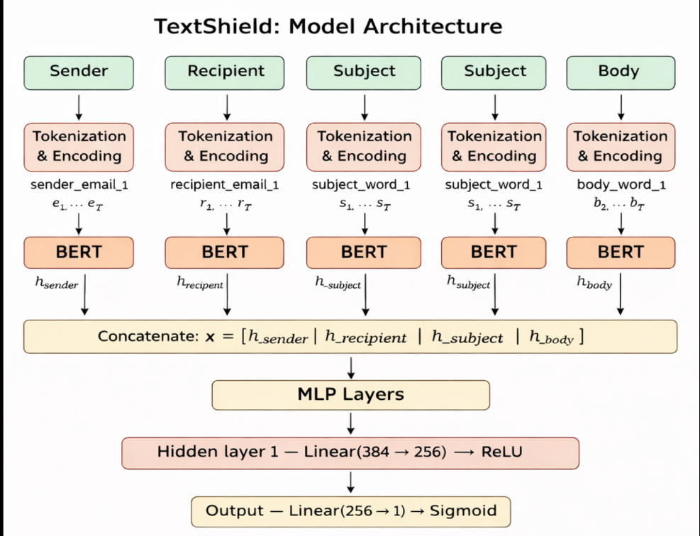
Fig. 2. Architecture of E2E-EmbedDetector. Entity embeddings for From, To, and ContractAddress are concatenated with numeric features and processed through a 3-layer MLP.

Training Configuration
The model is optimized using BCEWithLogitsLoss (binary cross-entropy with logits), which combines the sigmoid activation and the loss computation in a single numerically stable operation. Although the dataset is balanced, a pos_weight parameter is retained in the loss function as a robustness mechanism, enabling rapid adaptation to datasets with class imbalance without architectural changes. The Adam optimizer is used with an initial learning rate of 1×10⁻³ and default momentum parameters (β1 = 0.9, β2 = 0.999). A ReduceLROnPlateau scheduler monitors validation PR-AUC at the end of each epoch and reduces the learning rate by a factor of 0.5 if no improvement is observed for three consecutive epochs. Training proceeds for a maximum of 50 epochs with early stopping triggered after 5 epochs without PR-AUC improvement on the validation set, preventing overfitting while allowing sufficient convergence time.

Threshold Optimization
The sigmoid output of the model is a continuous probability score in [0, 1]. Converting this score to a binary classification decision requires selecting a decision threshold τ. The default choice of τ = 0.5 is suboptimal for detection tasks: in phishing detection, the cost of a false negative (missing a real attack) substantially exceeds the cost of a false positive (flagging a benign transaction). To find a better operating point, we perform a threshold sweep over τ ∈ {0.01, 0.02, ..., 0.99} on the validation set and select τ* = argmax_τ F1(τ). This procedure yields τ* ≈ 0.60 for our model, reflecting a slight shift toward higher confidence before predicting phishing—consistent with the model's high recall at this threshold.

Experimental Setup

Train/Validation Split
The labeled dataset is partitioned into training (80%) and validation (20%) subsets using a stratified random split, ensuring that both partitions maintain the 1:1 class ratio present in the full dataset. Stratification prevents pathological splits where one class is underrepresented in validation, which would produce unreliable estimates of precision and recall.
We acknowledge two important limitations of this split strategy. First, random splits do not enforce address disjointness: the same Ethereum address may appear in both the training and validation sets. Since the model learns address-specific embeddings, this overlap allows partial memorization of entity-label associations, which may inflate reported metrics beyond what would be observed on genuinely unseen addresses. Second, random splits do not respect temporal order: training transactions may postdate validation transactions, allowing the model to indirectly learn from future behavioral patterns. Both issues are well-known in the transaction fraud and phishing detection literature [1][8] and represent important directions for future evaluation rigor.

Evaluation Metrics
Six metrics are reported: Accuracy (fraction of correctly classified transactions), Precision (fraction of predicted-phishing transactions that are truly phishing), Recall (fraction of actual phishing transactions that are detected), F1-score (harmonic mean of precision and recall, used for threshold selection), ROC-AUC (area under the receiver operating characteristic curve, measuring discrimination across all thresholds), and PR-AUC (area under the precision-recall curve, also known as Average Precision). PR-AUC receives particular emphasis because it captures classifier quality in the high-precision and high-recall regimes simultaneously, making it more informative than ROC-AUC when detection reliability across operating points is the primary concern.

Hyperparameter Settings
All hyperparameters were set prior to training and held fixed: embedding dimension d = 32 per entity field; hidden layer dimensions 128 → 128 → 64; dropout rate p = 0.3 applied after each ReLU; batch size 64; maximum epochs 50; early stopping patience 5; learning rate 1×10⁻³ with ReduceLROnPlateau factor 0.5 and patience 3. No hyperparameter search was performed; these values were chosen based on standard practice for tabular neural networks and held constant to avoid overfitting to the validation set.

Results
Table I summarizes the full suite of validation metrics obtained by E2E-EmbedDetector after training to convergence. The model achieves strong discriminative performance across all reported metrics, with ROC-AUC and PR-AUC both reaching 0.991 and an F1-score of 0.958 at the optimized decision threshold of τ* ≈ 0.60.
- Validation Performance Of E2E-EmbedDetector
Metric | Value
Accuracy | 0.9563
Precision | 0.9265
Recall | 0.9912
F1-Score | 0.9578
ROC-AUC | 0.9915
PR-AUC | 0.9909
Best Threshold | ~0.60
Fig. 3. Confusion matrix of E2E-EmbedDetector on the validation set (threshold ≈ 0.60). High true-positive rate reflects the model's strong phishing recall.
The high recall (0.991) indicates that the model successfully identifies nearly all phishing transactions in the validation set, missing fewer than 1% of true positives. The modest gap between precision (0.927) and recall (0.991) suggests a small but non-zero false positive rate: approximately 7.3% of transactions flagged as phishing are in fact benign. In an operational deployment context, this trade-off is generally acceptable—false positives generate warnings that a human analyst can review, while false negatives allow attacks to proceed undetected.
The near-identical ROC-AUC (0.991) and PR-AUC (0.991) values are particularly noteworthy. On balanced datasets, PR-AUC and ROC-AUC often diverge, with PR-AUC being more sensitive to false positive performance at high recall. Their convergence here suggests that E2E-EmbedDetector maintains well-calibrated precision across the full recall spectrum, not merely at the chosen operating point. This property is important for deployments where the decision threshold may need to be adjusted to meet different security policies.
The model converges reliably across training runs. Early stopping is triggered before the 50-epoch ceiling in all experiments, with the best validation checkpoint typically reached between epochs 15 and 30. This fast convergence reflects the effectiveness of entity embeddings as a compact, information-dense representation: the model does not need to learn complex feature interactions from scratch but instead leverages the structural signal already encoded in the address co-occurrence patterns.

Comparison With TEGDetector
- Conceptual Comparision With TEGDetector
Feature / Aspect | TEGDetector | E2E-EmbedDetector (This Work)
Ethereum transaction data | Yes | Yes
Entity info (From/To) | Yes | Yes
Contract address handling | Implicit | Yes (sentinel embedding)
Explicit time slicing | Yes | No
Temporal evolution modeling | Yes | No
TEG graph construction | Yes | No
Dynamic graph classifier | Yes | No
Entity embeddings (core design) | No | Yes
Single-stage end-to-end training | No | Yes
Lightweight inference | No | Yes
Deployment simplicity | Moderate | High

Table II highlights the central trade-off: TEGDetector provides methodologically richer temporal modeling through explicit time slicing and dynamic graph classification, making it well-suited for detecting behavioral drift. E2E-EmbedDetector instead prioritizes deployment simplicity—single-stage training, fast tabular inference, and minimal preprocessing—while achieving competitive accuracy on this dataset.
A direct accuracy comparison is deferred to future work, as a valid head-to-head evaluation requires matched datasets and stricter splits (address-disjoint or time-based), neither of which is established in the current experimental setup.

Threats to Validity

Entity leakage
The stratified random split does not enforce address disjointness between training and validation sets. Because the model learns a dedicated embedding vector for each address in the training vocabulary, any address that appears in both partitions effectively allows the model to memorize the label associated with that address rather than generalizing from its structural context. Address-disjoint splits—where no address appears in both partitions—are the correct mitigation and are recommended for future evaluation.

Temporal leakage
A random split ignores the temporal ordering of transactions encoded in the BlockHeight and TimeStamp fields. In practice, phishing campaigns evolve over time: attack strategies, contract patterns, and victim targeting all shift. A model trained on randomly mixed transactions from the full-time range will have indirect access to future behavioral patterns when evaluated on an interleaved validation set. Time-based splits—where the training set contains only earlier transactions and the validation set contains only later ones—more faithfully simulate deployment conditions and are better suited to measuring temporal generalization.

Label reliability
All conclusions rest on the assumption that Class = 1 accurately identifies phishing-associated transactions. In practice, ground-truth labels for blockchain phishing datasets are often derived from blacklists, heuristic rules, or community reports, and may contain both false positives (benign transactions incorrectly flagged) and false negatives (phishing transactions missed by the labeling process). Label noise of either type would affect all reported metrics and could cause the model to learn incorrect decision boundaries.

Distribution shift
Phishing tactics on Ethereum are not static. New scam variants—such as approval phishing, honeypot contracts, and flash-loan exploits—emerge continuously, and the statistical signature of phishing in transaction records may shift substantially across different time periods, chain upgrades, or market conditions. Performance measured on a single balanced snapshot may not predict detection rates on future or out-of-distribution transactions.

Conclusion
This work presented E2E-EmbedDetector, a lightweight, deployable end-to-end neural model for Ethereum phishing detection. The model learns compact entity embeddings for the From, To, and ContractAddress fields of raw transaction records, combines them with two normalized numeric features (Value and InputLength), and classifies each transaction through a three-layer MLP with Batch Normalization and Dropout regularization. Trained on a balanced corpus of 50,000 Ethereum transactions using a stratified 80/20 split, the model achieves an accuracy of 95.6%, an F1-score of 0.958, and ROC-AUC and PR-AUC values of 0.991 at an optimized decision threshold of τ* ≈ 0.60.
The central finding of this work is that competitive phishing detection performance is achievable without constructing explicit transaction graphs, time-slicing transaction histories, or employing dynamic graph classifiers. By treating address fields as categorical entities and learning their representations end-to-end, E2E-EmbedDetector captures the relational signals that graph-based methods encode structurally—but does so within a single-stage, tabular training pipeline that is simpler to implement, faster to train, and easier to deploy in production environments.
Compared to TEGDetector [1], which explicitly models behavioral evolution through time-sliced TEGs and dynamic graph attention, E2E-EmbedDetector occupies a complementary position: it sacrifices explicit temporal modeling in exchange for deployment simplicity and inference speed. Neither approach strictly dominates the other; the right choice depends on the operational constraints of the target deployment. For environments where real-time scoring of high-throughput transaction streams is required, the tabular architecture offers clear advantages. For settings where offline analysis of evolving phishing campaigns is the goal, temporal graph models may be more expressive.
Future work:
Several extensions would strengthen the claims in this work. First, evaluation under address-disjoint and time-based splits would provide a more conservative and realistic estimate of generalization performance and enable fair comparison with temporal graph methods. Second, reproducing the TEGDetector baseline on the same dataset and splits would allow a rigorous quantitative comparison rather than the conceptual comparison presented here. Third, incorporating lightweight temporal signals—such as sinusoidal time embeddings derived from TimeStamp, windowed address-level transaction count aggregates, or recurrent sequence models over address history—would bridge the gap between the simplicity of E2E-EmbedDetector and the temporal expressiveness of TEGDetector, potentially combining the strengths of both paradigms.

Acknowledgement
The authors used Claude, an AI-based language model developed by Anthropic, for assistance with language refinement and formatting during the preparation of this manuscript. All technical content, analysis, and conclusions were reviewed and validated by the authors, who take full responsibility for the final content.

References
[1] J. Chen, H. Xiong, D. Zhang, Z. Liu, and J. Wu, "TEGDetector: A phishing detector that knows evolving transaction behaviors," arXiv:2111.15446v1, Nov. 2021.
[2] Seaocn, "TEGDetector (GitHub Repository)," 2021. [Online]. Available: https://github.com/Seaocn/TEGDetector
[3] W. Chen, X. Guo, Z. Chen, Z. Zheng, and Y. Lu, "Phishing scam detection on Ethereum: Towards financial security for blockchain ecosystem," in Proc. 29th Int. Joint Conf. Artif. Intell. (IJCAI), 2020, pp. 4506–4512.
[4] L. Chen, J. Peng, Y. Liu, J. Li, F. Xie, and Z. Zheng, "Phishing scams detection in Ethereum transaction network," ACM Trans. Internet Technol., vol. 21, no. 1, pp. 1–16, 2021.
[5] P. Li, Y. Xie, X. Xu, J. Zhou, and Q. Xuan, "Phishing fraud detection on Ethereum using graph neural network," in Proc. Int. Conf. Blockchain and Trustworthy Systems (BlockSys), Springer, 2022, pp. 362–375.
[6] S. Li, G. Gou, C. Liu, C. Hou, Z. Li, and G. Xiong, "TTAGN: Temporal transaction aggregation graph network for Ethereum phishing scams detection," in Proc. ACM Web Conf. (WWW), 2022, pp. 661–669.
[7] A. H. H. Kabla, M. Anbar, S. Manickam, and S. Karuppayah, "Eth-PSD: A machine learning-based phishing scam detection approach in Ethereum," IEEE Access, vol. 10, pp. 118043–118057, 2022.
[8] Z. Lin, X. Xiao, G. Hu, Q. Li, B. Zhang, and X. Luo, "Tracking phishing on Ethereum: Transaction network embedding approach for accounts representation learning," Comput. Secur., vol. 135, p. 103479, 2023.
[9] T. Wen, Y. Xiao, A. Wang, and H. Wang, "A novel hybrid feature fusion model for detecting phishing scam on Ethereum using deep neural network," Expert Syst. Appl., vol. 211, p. 118463, 2023.
[10] J. Wang, C. Chen, P. Yu, S., et al., "TSGN: Transaction subgraph networks for identifying Ethereum phishing accounts," in Proc. Int. Conf. Blockchain and Trustworthy Systems (BlockSys), Springer, 2021, pp. 187–200.
[11] Y. Xia, J. Liu, and J. Wu, "Phishing detection on Ethereum via attributed ego-graph embedding," IEEE Trans. Circuits Syst. II, Exp. Briefs, vol. 69, pp. 2538–2542, 2022.
[12] J. Wu, Q. Yuan, D. Lin, W. You, W. Chen, C. Chen, and Z. Zheng, "Who are the phishers? Phishing scam detection on Ethereum via network embedding," IEEE Trans. Syst. Man Cybern. Syst., vol. 52, pp. 1156–1166, 2022.

